https://tucson.com/news/opinion/guest-column-discriminatory-bills-show-it-s-time-for-anglos/article_442d3784- 41c4-51d1-876e-d59648772ac6.html
Guest Column: Discriminatory bills show it's time for Anglos, Latinos to pull together
Jo Holt and Deyanira Nevarez Martinez Special To The Arizona Daily Star Mar 17, 2013
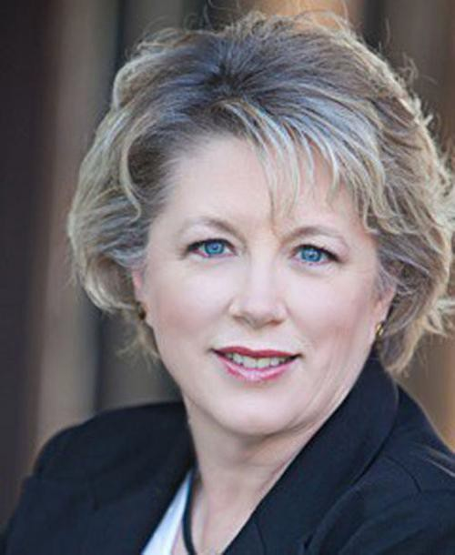
Jo Holt
Submitted Photo

The tone of political discourse in Arizona is important. It motivates some and discourages others, it influences elections, and it ultimately resonates within our state laws.

In the past few years, we watched as the pitch of politics changed from confident, nonjudgmental and relatively accepting to uncompromising, distrustful, and vindictive. For many of us, this year's Legislature offered some glimmer of hope that the vitriol within the Capitol building may begin to ease.

Unfortunately, we are still faced with proposed legislation that feeds on the powerful, politically motivating emotions of fear and distrust. The very people who argue for less government do not hesitate to make more government to protect themselves from other points-of-view and other cultures.

Consider SB 1003, which would make it a felony for anyone from a political organization or campaign to pick up and deliver an early ballot. And then there is SB 1261, which would remove voters from the Permanent Early Voting List if they failed to vote in two consecutive cycles.

Many persons who are eligible to vote are not informed on dates and deadlines of elections; there are a variety of reasons for this which includes the lack of effective outreach. The option to give your ballot to a representative of a party, nonprofit organization, or campaign allows for every vote to be counted. This has proved to be an important tool in increasing Latino voter turnout, for example.

And then consider HB 2293 and HB 2289, which would require hospitals and schools to report undocumented patients and students. Hospitals and schools have clear responsibilities to society to provide their services to those in need regardless of their circumstances, including the ability to pay. These bills will make it harder for teachers, nurses and doctors to do their jobs, and much more likely that Latinos will not get the care or the education that they need.

These are baldfaced acts of political opportunism. Legislation like this is intended to discourage Latinos from voting and participating in the civic process - a cynical and selfish priority that is meant to help keep the current legislature in power. Actions like this are neither new nor novel to Arizona, but still, with each additional blow it feels like we sink a little lower. These bills are stark reminders that we are represented by politicians, not leaders. You don't need to silence someone if you have the conviction that your beliefs are the strongest.

Arizonans should feel confident in our ability to revive our economy and restore our educational system. We must stop spending precious resources fighting an immigrant population that will actually help us rebuild from the Great Recession. Anglos and Latinos must join forces to prepare for the Arizona of the future, built on a strong infrastructure of public education, renewable energy, efficient transportation, and technology. It's time for us to adopt a new tone: Arizona belongs to all of us.

Jo Holt is a retired biochemist and chairwoman of the LD11 Democratic Committee. She lives in Oro Valley and was a candidate for State Senate in 2012. Deyanira Nevarez Martinez is chairwoman of Las Adelitas Arizona, a nonpartisan organization that

recruits, educates and mobilizes Latinas to participate in all levels of government and support progressive issues.

